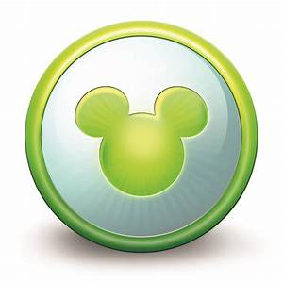 | Fastpass+ Tiers and Recommendations

Magic Kingdom
No Tier System | The Many Adventure of Winnie the Pooh
*Seven Dwarfs Mine Train | Haunted Mansion
*Peter Pan’s Flight | Barnstormer
*Space Mountain | It’s a Small World
*Enchanted Tales with Belle | Pirates of the Caribbean
*Splash Mountain | Jungle Cruise
*Big Thunder Mountain Railroad | Tomorrowland Speedway
Meet Mickey at Toon Square Theater | Meet Ariel at her Grotto
Meet Cinderella and Elena at Princess Fairytale Hall | Under the Sea – Journey of the Little Mermaid
Meet Rapunzel and Tiana at Princess Fairytale Hall | Meet Tinker Bell at Town Square Theater
Buzz Lightyear’s Space Ranger Spin | Dumbo
Mad Tea Party | Monster’s Inc Laugh Floor
Magic Carpets of Aladdin | PhilharMagic

Epcot
Tier One | Tier Two
*Frozen Ever After | Disney & Pixar Short Film Festival
Illuminations: Reflections of Earth | Journey into Imagination with Figment
*Soarin’ | Living with the Land
*Test Track | *Meet Disney Pals at the EPCOT Character Spot
 | Mission: Space
 | *Spaceship Earth
 | The Seas with Nemo and Friends
 | Turtle Talk with Crush

Animal Kingdom
Tier One | Tier Two
*Avatar Flight of Passage | *Expedition Everest
*Na’vi River Journey | Dinosaur
 | It’s Tough to be a Bug
 | Kali River Rapids
 | *Kilimanjaro Safaris
 | Primeval Whirl
 | UP! A Great Bird Adventure
 | Meet Favorite Disney Pals at Adventures Outpost

Hollywood Studios
Tier One | Tier Two
*Toy Story Mania | Disney Junior – Live on Stage!
*Slinky Dog Dash | Indiana Jones Epic Stunt Spectacular
*Alien Swirling Saucers | Muppet Vision 3D
 | Star Tours – The Adventures Continue
 | *The Twilight Zone Tower of Terror
 | For the First Time in Forever: A Frozen Sing-Along Celebration
 | Voyage of the Little Mermaid
 | Fantasmic!
 | Beauty and the Beast – Live on Stage
 | *Rock ‘n’ Roller Coaster Starring Aerosmith

* Recommended Fastpass – Try to grab these first, if possible

For Each Park – You may choose 1 Tier One Attraction and 2 Tier Two Attractions. OR you may choose 3 Tier Two Attractions if you do not want any Tier One Attractions.

